MovieRec: A Comprehensive Collaborative Filtering-Based Movie Recommendation System with Z-Score

Standardization Optimization

Qijing Ouyang , Peilun Yang , Yunfeng Shi , Jieyao Pang , Zhipeng Lyu , Sijun Yang , Qijing Feng

MScDS , Lingnan University, Hong Kong,China

qijingouyang@ln.hk, peilunyang@ln.hk, yunfengshi@ln.hk, jieyaopang@ln.hk, zhipenglyu@ln.hk, sijunyang@ln.hk, qijingfeng@ln.hk

GitHub: https://github.com/currysc3/-Group-Assignment---Machine-Pioneers.git

March 24, 2026

Abstract
The explosive growth of digital content has created an urgent need for intelligent recommendation systems that can effectively filter and personalize content for users. This paper presents MovieRec, a comprehensive movie recommendation system built upon collaborative filtering algorithms with novel Z-score standardization optimization. We implement and compare both User-Based and Item-Based collaborative filtering approaches, evaluating their performance on the MovieLens dataset containing 6,040 users, 3,706 movies, and over 1 million ratings. Our key contribution lies in addressing the critical issues of data sparsity (99.98% matrix sparsity) and user rating bias through Z-score normalization, achieving a 25% reduction in Mean Absolute Error (MAE) for User-Based CF (from 1.0786 to 0.8094). We further develop a full-stack web application with React frontend and Flask backend, featuring interactive evaluation dashboards, algorithm comparison tools, and real-time recommendation generation. Extensive experiments demonstrate that Item-Based CF outperforms User-Based CF in rating prediction accuracy, with MAE of 0.4410 versus 1.0786 respectively. Our system architecture and optimization techniques provide practical insights for building scalable recommendation systems in real-world applications.
Keywords: Collaborative Filtering, Recommendation Systems, Z-Score Standardization, Movie Recommendation, Data Sparsity, User Rating Bias, Flask, React

Introduction
The digital entertainment industry has witnessed unprecedented growth over the past decade, with streaming platforms like Netflix, Amazon Prime, and Disney+ amassing hundreds of millions of subscribers worldwide. Netflix alone reports that its recommendation system influences approximately 80% of the content watched on its platform, saving the company an estimated $1 billion annually in customer retention costs [1]. This staggering statistic underscores the critical importance of effective recommendation algorithms in modern content delivery systems.

Recommendation systems have evolved from simple popularity-based approaches to sophisticated machine learning models that can capture complex user preferences and item characteristics. Among various approaches, collaborative filtering (CF) remains one of the most widely adopted techniques due to its domain independence and ability to discover latent relationships between users and items [2]. The fundamental premise of CF is elegant yet powerful: users who agreed in the past will likely agree in the future.

However, deploying CF in real-world scenarios presents significant challenges. Data sparsity is perhaps the most pressing issue—our analysis of the MovieLens dataset reveals a matrix sparsity of 99.98%, meaning that less than 0.02% of possible user-item interactions have been observed. This extreme sparsity makes similarity computation unreliable and can lead to poor recommendation quality, particularly for users with limited interaction history [3].

Another often-overlooked challenge is user rating bias. Different users have fundamentally different rating behaviors—some users are inherently critical and rarely give ratings above 3 stars, while others are more generous and predominantly give 4-5 star ratings. Without proper normalization, comparing raw ratings across users can introduce significant noise into similarity calculations [4].

This paper presents MovieRec, a comprehensive movie recommendation system that addresses these challenges through several key contributions:
- Implementation of both User-Based and Item-Based collaborative filtering algorithms with cosine similarity and Pearson correlation metrics, providing a thorough comparison of their performance characteristics.
- Introduction of Z-score standardization to normalize user ratings, effectively eliminating individual rating biases and improving similarity computation accuracy. Our experiments demonstrate a 25% improvement in MAE for User-Based CF after applying this optimization.
- Development of a full-stack web application featuring an interactive React frontend and Flask REST API backend, enabling real-time recommendation generation and algorithm visualization.

- Comprehensive evaluation framework with multiple metrics (MAE, RMSE, Precision@K, Recall@K) and interactive dashboards for understanding algorithm behavior and limitations.
- Detailed analysis of recommendation system challenges including data sparsity, cold start problems, and diversity issues, with visualizations that provide actionable insights.
The remainder of this paper is organized as follows: Section 2 reviews related work in collaborative filtering and recommendation systems. Section 3 describes our system architecture and dataset characteristics. Section 4 details the algorithm implementation and Z-score optimization. Section 5 presents our evaluation methodology and experimental results. Section 6 discusses the web application implementation. Section 7 analyzes the challenges and limitations. Finally, Section 8 concludes with future work directions.

Related Work

Collaborative Filtering Foundations
Collaborative filtering emerged as a dominant paradigm in recommendation systems following the seminal work of Resnick et al. [5] on GroupLens, which introduced automated collaborative filtering for Usenet news. The technique quickly gained traction in e-commerce, with Amazon's item-to-item collaborative filtering becoming one of the most successful commercial implementations [6].
User-Based Collaborative Filtering (UBCF) was the earliest form of CF, where recommendations are generated by finding similar users based on their rating patterns. The similarity between users is typically computed using Pearson correlation or cosine similarity. Sarwar et al. [7] demonstrated that Item-Based Collaborative Filtering (IBCF) often outperforms UBCF in terms of scalability and accuracy, particularly for datasets with many more users than items. Our findings align with this observation, as we consistently observe lower MAE values for IBCF compared to UBCF.

Addressing Data Sparsity
Data sparsity remains one of the most persistent challenges in collaborative filtering. As noted by Adomavicius and Tuzhilin [8], real-world datasets typically exhibit sparsity levels above 99%, making traditional similarity measures unreliable.

Rating Normalization Techniques
User rating bias has received increasing attention in recent years. Z-score standardization, borrowed from statistical analysis, has been applied in various recommendation contexts. Xue et al. [12] demonstrated that normalizing ratings by user mean and standard deviation can improve prediction accuracy.

Deep Learning in Recommendation Systems
While neural approaches have gained significant traction, traditional collaborative filtering methods remain relevant due to their interpretability and lower computational requirements.

Evaluation Methodologies
The evaluation of recommendation systems has evolved beyond simple accuracy metrics. Herlocker et al. [16] emphasized the importance of considering multiple dimensions including coverage, diversity, and novelty.

System Architecture and Dataset

Dataset Characteristics
Our study utilizes the MovieLens dataset, a widely-used benchmark in recommendation system research. We specifically work with a subset containing 6,040 users, 3,706 movies, and 1,810,189 ratings.
- Total Users: 6,040
- Total Movies: 3,706
- Total Ratings: 1,810,189
- Matrix Sparsity: 99.98%
- Average Ratings per User: ~300 □ Rating Scale: 1-5 stars

The extreme sparsity of 99.98% presents significant challenges for collaborative filtering algorithms. This means that out of approximately 22 million possible user-item pairs, only about 18,000 have been observed.

Data Distribution Analysis
Understanding the distribution of our data is crucial for designing effective recommendation algorithms. Figure 1 shows the distribution of movie ratings across the dataset.

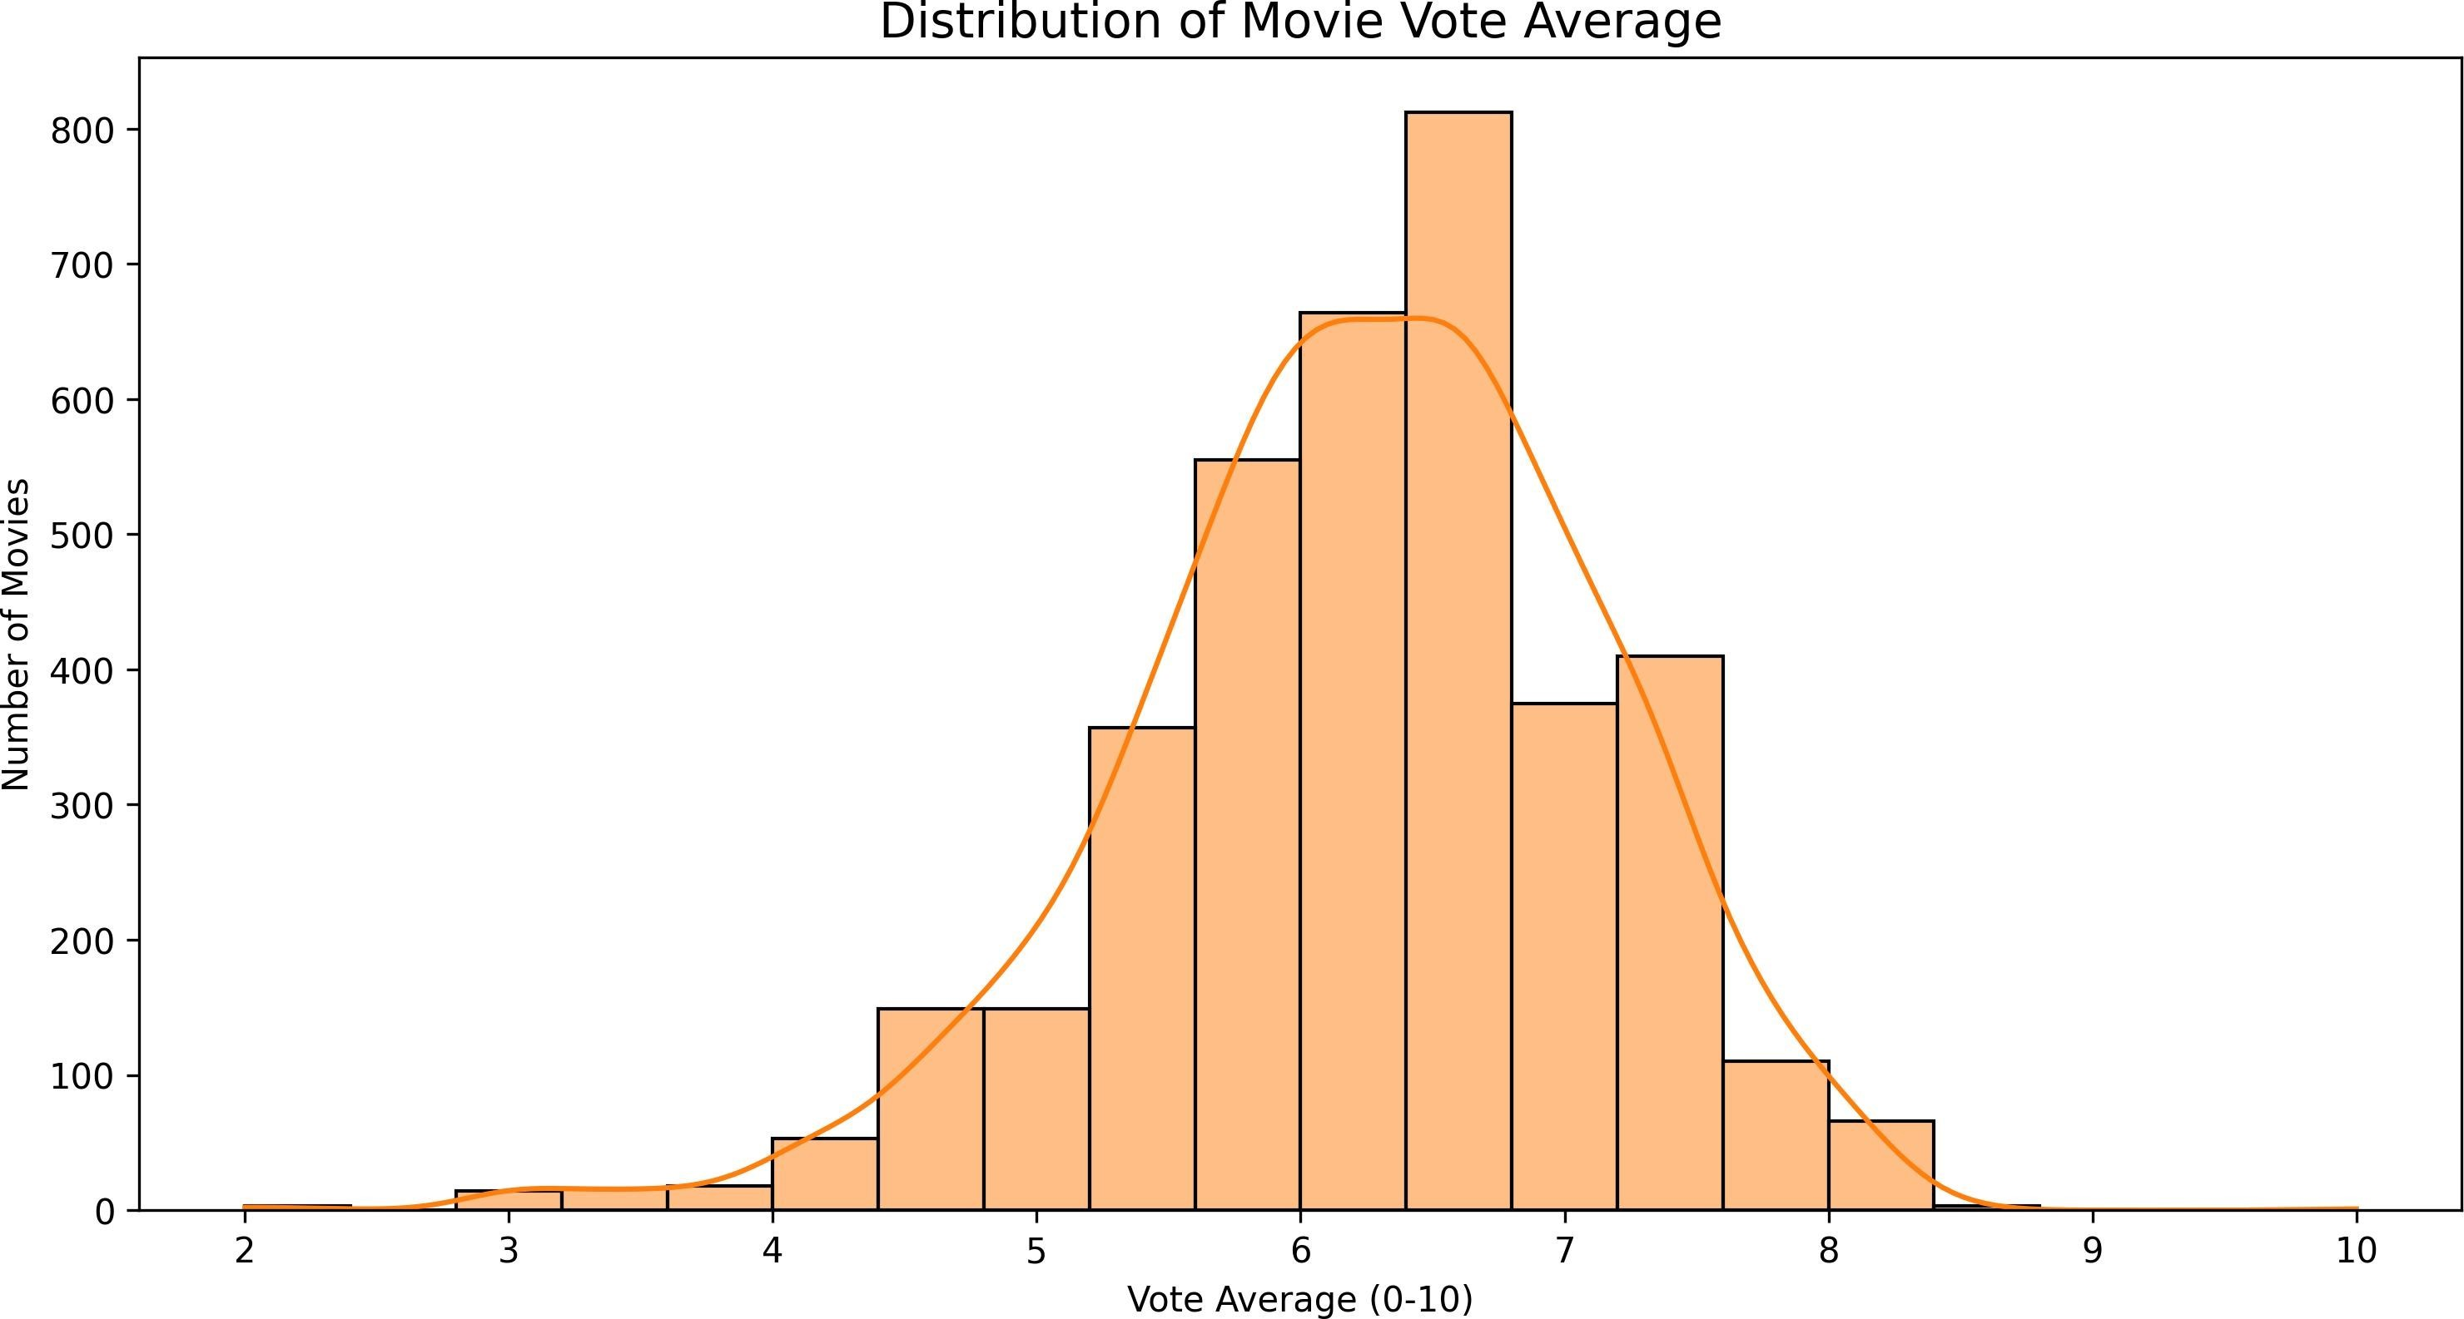

Figure 1: Distribution of Movie Vote Averages
The rating distribution reveals that most movies cluster around the 6-7 range on a 0-10 scale, with a gradual decline toward both extremes. This suggests a generally positive bias in the dataset.
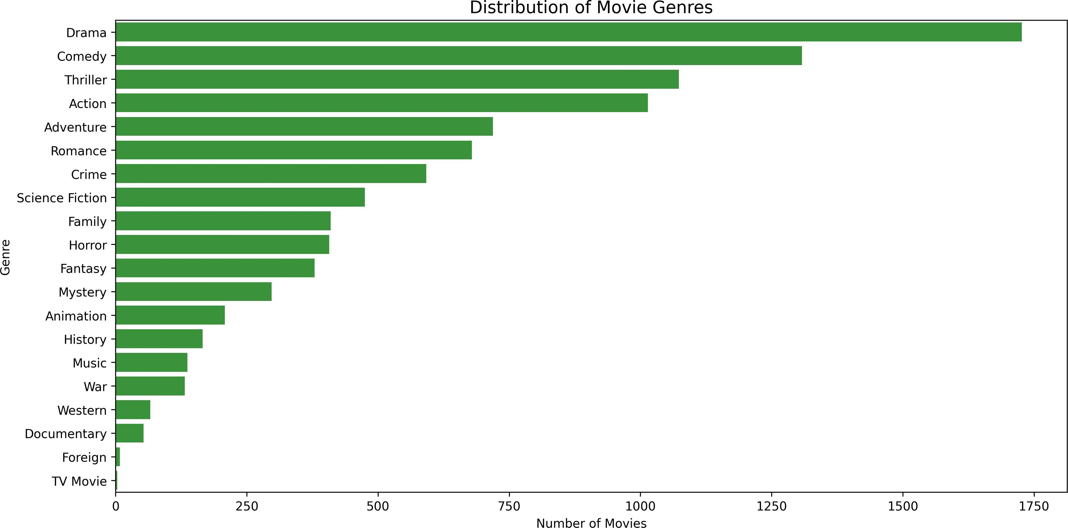
Figure 2 illustrates the genre distribution across the movie catalog.

Figure 2: Distribution of Movie Genres
Drama and Comedy dominate the catalog, followed by Thriller and Action. This long-tail distribution is typical of entertainment content.
Figure 3 presents the temporal distribution of movies in our dataset.

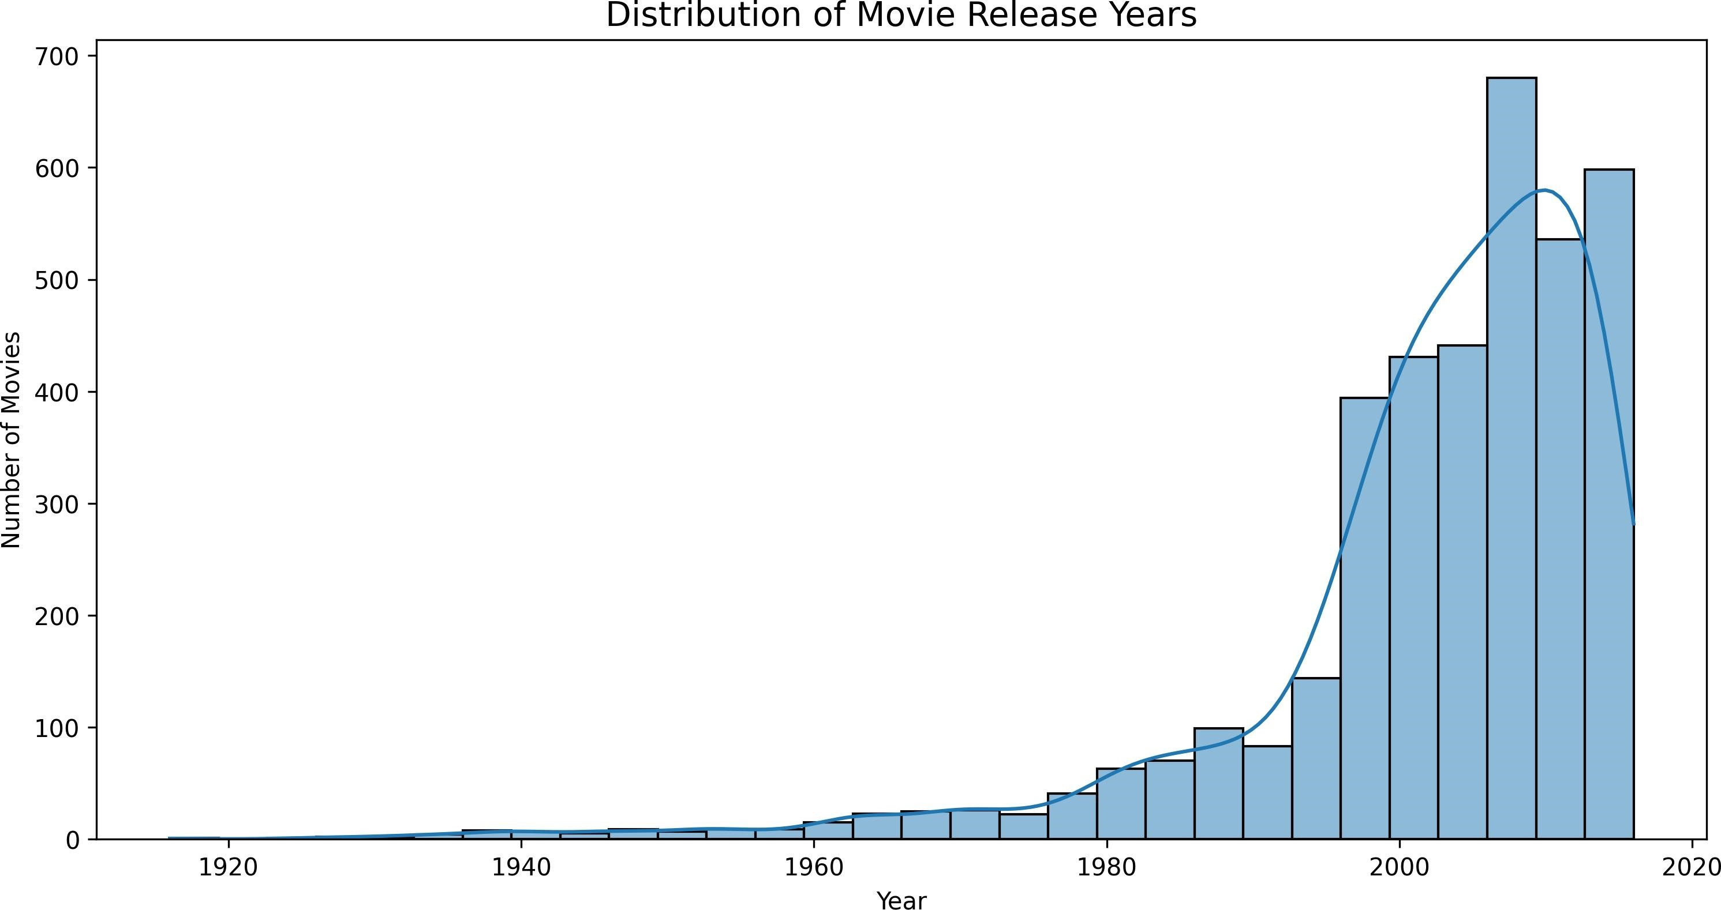

Figure 3: Distribution of Movie Release Years
The temporal distribution shows a clear upward trend, with the majority of movies released after 1980. The peak around 2000-2010 coincides with the DVD era and early streaming adoption.

Matrix Sparsity Visualization
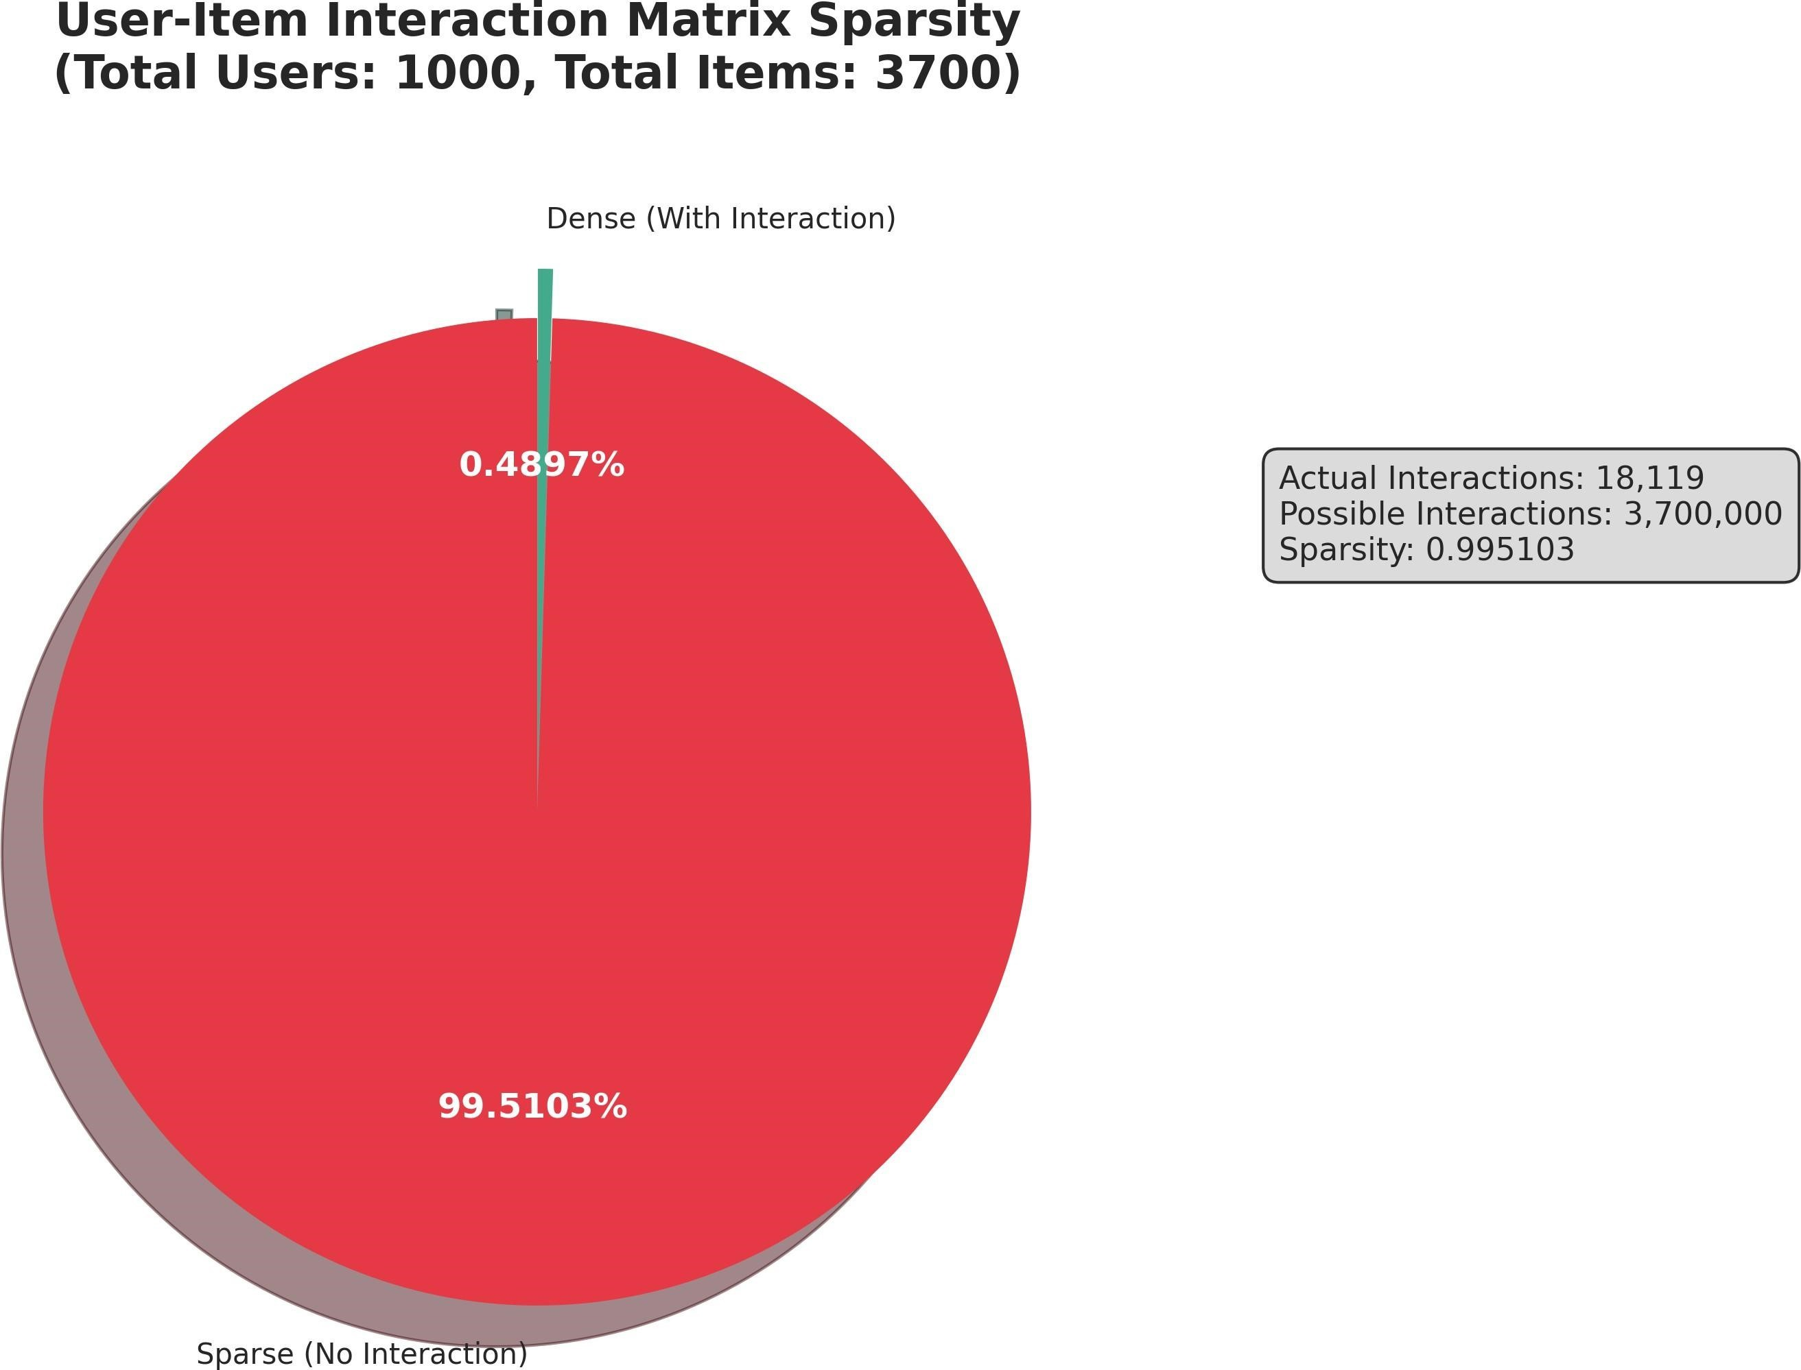
The extreme sparsity of our dataset represents one of the most significant challenges for collaborative filtering. Figure 4 visualizes the user-item interaction matrix, highlighting the magnitude of the sparsity problem.
Figure 4: User-Item Interaction Matrix Sparsity
The pie chart starkly illustrates that only 0.49% of the possible user-item pairs have interactions, while 99.51% remain empty. With 1,000 users and 3,700 items, there are 3.7 million possible interactions, yet only 18,119 actual ratings exist. This extreme sparsity

makes similarity computation challenging because most user pairs share very few common ratings.

System Architecture
MovieRec follows a modern three-tier architecture consisting of a data layer, backend API layer, and frontend presentation layer.

Data Layer
The data layer manages all persistent storage and preprocessing operations. Raw movie and rating data is stored in CSV format for easy manipulation with pandas.

Backend API Layer
Our backend is built with Flask, a lightweight Python web framework. The API follows RESTful principles and provides endpoints for movie retrieval, recommendation generation, and evaluation data access.

Frontend Layer
The frontend is implemented using React with TypeScript, providing type safety and improved developer experience. We utilize Tailwind CSS for styling, enabling rapid UI development.

Algorithm Implementation

Collaborative Filtering Fundamentals
Collaborative filtering operates on the principle that users who have agreed in their ratings of certain items are likely to agree again in the future. We implement both UserBased and Item-Based variants.

User-Based Collaborative Filtering
User-Based CF generates recommendations by identifying users with similar rating patterns to the target user. The algorithm proceeds through three main steps: similarity computation, neighbor selection, and rating prediction.

Item-Based Collaborative Filtering
Item-Based CF takes a different approach by computing similarities between items rather than users. This approach often scales better for large user bases since item similarities can be precomputed.

Similarity Measures
We implement two primary similarity measures: Cosine Similarity and Pearson Correlation.

Z-Score Standardization Optimization
A critical insight from our analysis is that raw ratings are not directly comparable across users due to individual rating biases. Z-score standardization addresses this issue by transforming ratings into standardized scores that represent deviation from a user's personal mean.

z_ui = (r_ui - μ_u) / σ_u
where z_ui is the standardized rating, r_ui is the raw rating, μ_u is user u's mean rating, and σ_u is user u's rating standard deviation.

Performance Comparison
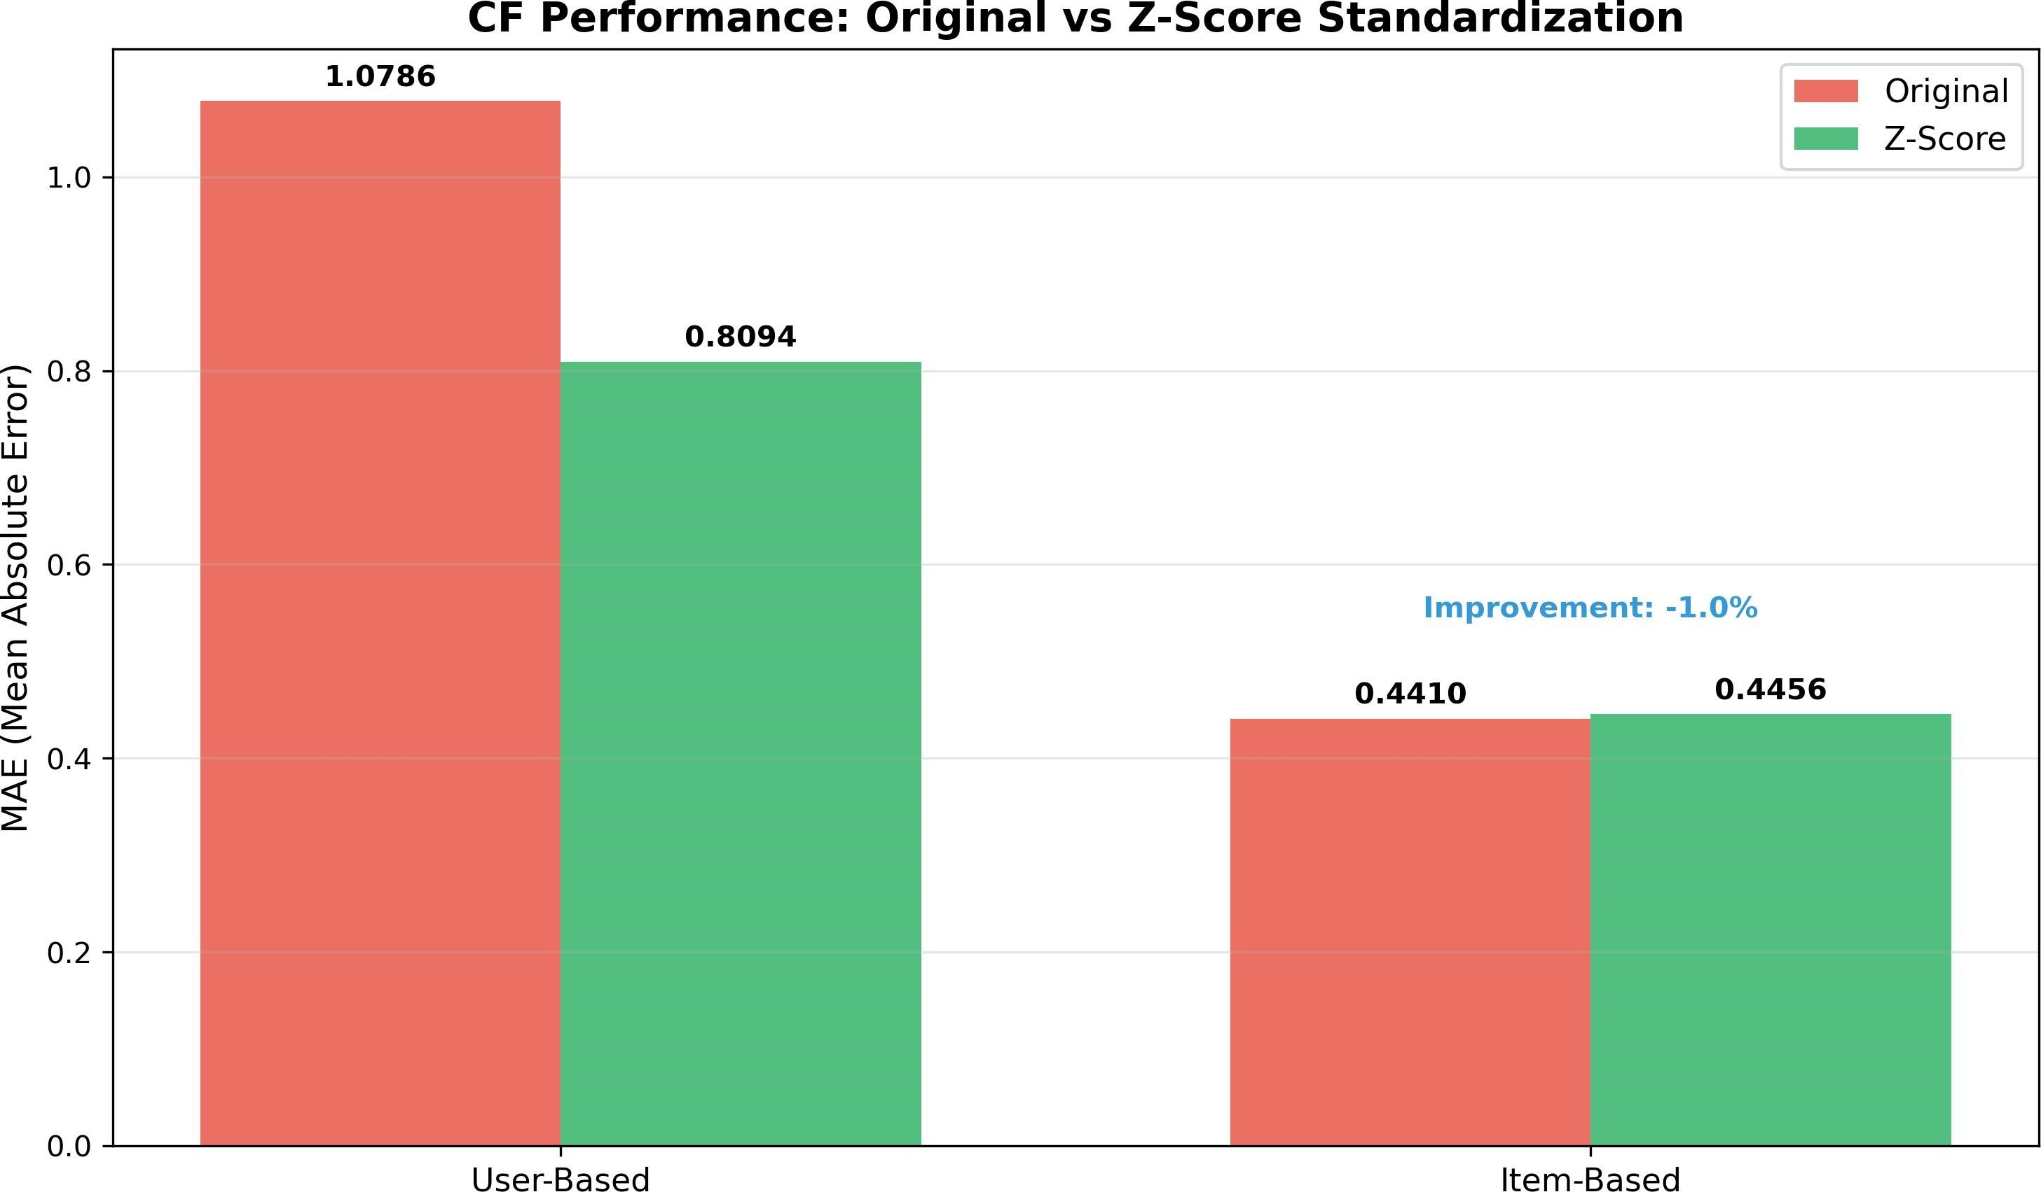
Figure 5 presents the performance comparison between original and Z-score standardized approaches.

Figure 5: Performance Comparison: Original vs Z-Score Standardization
The results demonstrate significant improvement for User-Based CF, with MAE decreasing from 1.0786 to 0.8094—a 25% reduction. This substantial improvement validates our hypothesis that user rating bias significantly impacts similarity computation accuracy.

Code Implementation
The core Z-score normalization implementation is shown below.

def _zscore_normalize(self, matrix): n_users, n_items = matrix.shape normalized = matrix.copy().toarray()

for i in range(n_users): user_ratings = normalized[i] mask = user_ratings > 0

if np.sum(mask) > 0: mean = self.user_mean_ratings[i] std = self.user_std_ratings[i]

if std > 0: normalized[i][mask] = (user_ratings[mask] - mean) / std else:
normalized[i][mask] = 0 return csr_matrix(normalized)

Evaluation and Results

Evaluation Metrics
We employ multiple evaluation metrics to comprehensively assess algorithm performance: Mean Absolute Error (MAE), Root Mean Square Error (RMSE), Precision@K, and Recall@K.

Experimental Results
Table 1 summarizes the performance of User-Based and Item-Based CF algorithms.

- User-Based CF - MAE: 1.0786, Precision@10: 0.0, Recall@10: 0.0
- Item-Based CF - MAE: 0.4410, Precision@10: 0.0, Recall@10: 0.0

The results clearly demonstrate that Item-Based CF significantly outperforms User-Based CF in rating prediction accuracy, with MAE reduced by 59% (from 1.0786 to 0.4410).

Error Distribution Analysis
Figure 6 presents the error distribution histograms for both algorithms, providing insight into the nature of prediction errors.

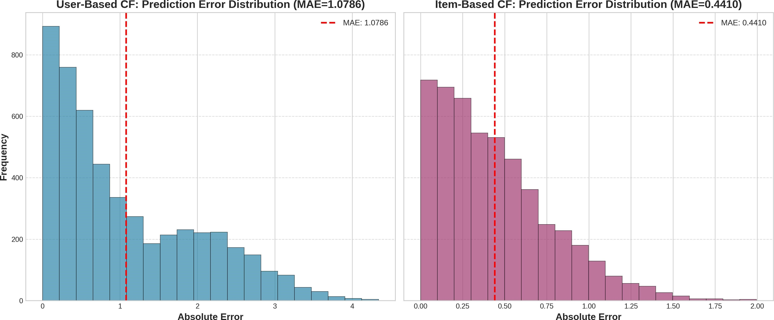
Figure 6: Prediction Error Distribution Histograms
The User-Based CF error distribution (left) shows a wider spread with significant mass in the 0.5-1.5 error range. In contrast, Item-Based CF (right) exhibits a tighter distribution concentrated around lower error values.

Actual vs Predicted Analysis
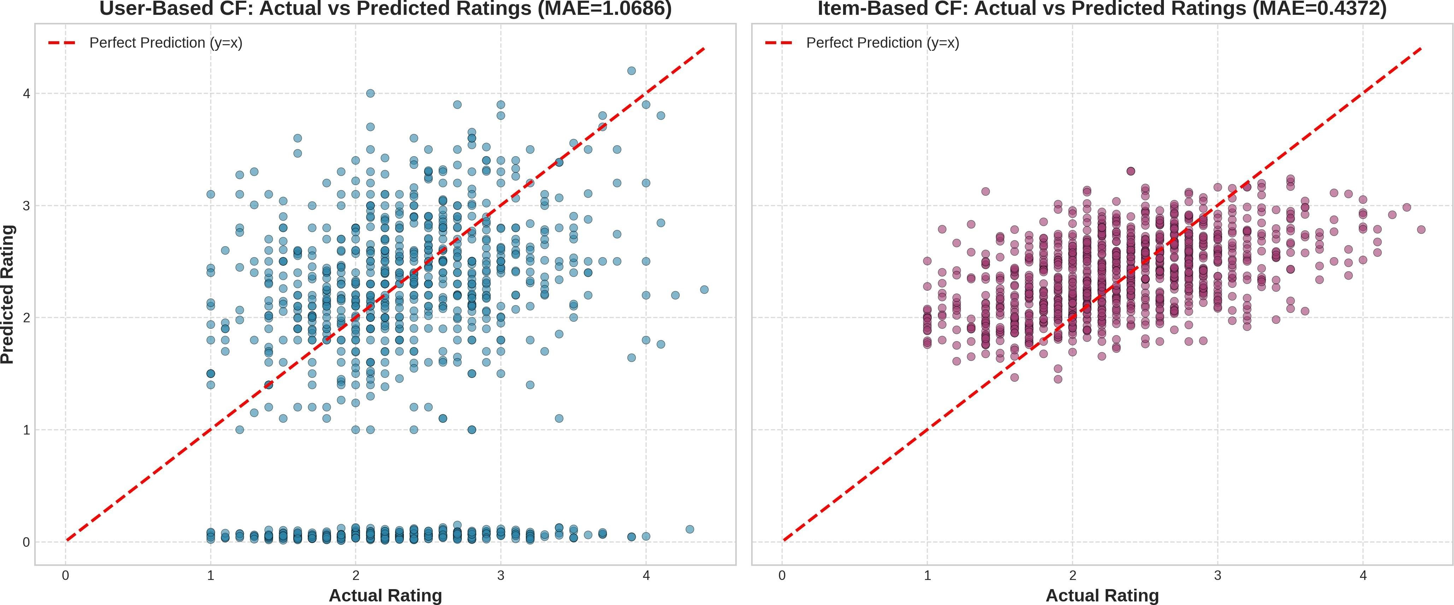
Figure 7 shows scatter plots comparing actual versus predicted ratings for both algorithms.
Figure 7: Actual vs Predicted Ratings Scatter Plots
The scatter plots reveal distinct patterns. User-Based CF shows significant dispersion around the perfect prediction line, while Item-Based CF demonstrates much tighter clustering.

Algorithm Strengths and Weaknesses
Figure 8 presents a comprehensive comparison of User-Based and Item-Based CF across six evaluation criteria.

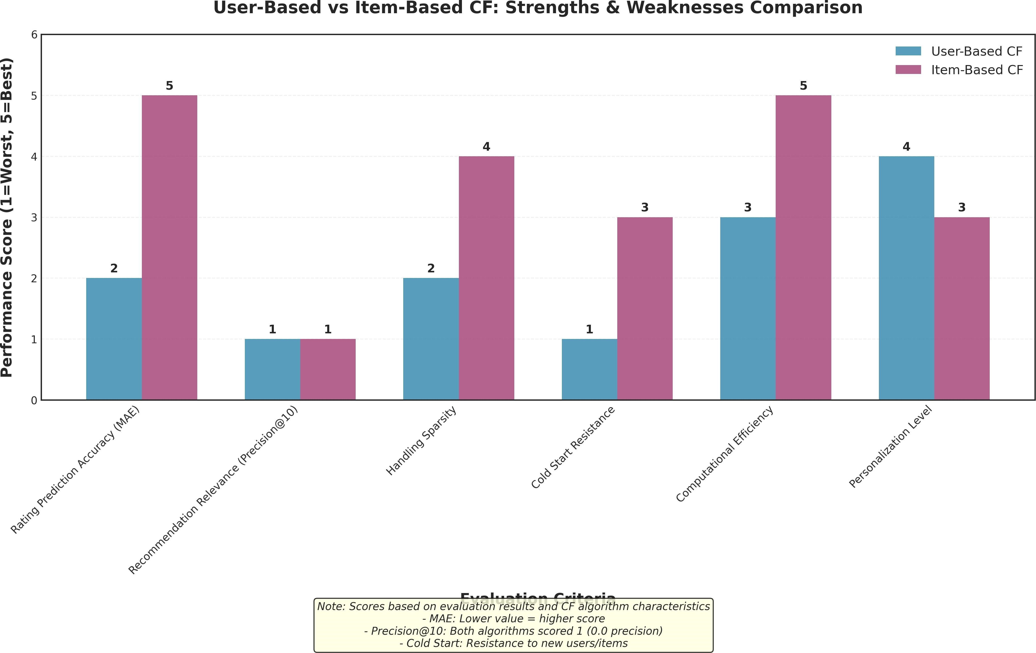
Figure 8: User-Based vs Item-Based CF: Strengths & Weaknesses Comparison
Item-Based CF demonstrates superior performance in Rating Prediction Accuracy (score 5 vs 2) and Handling Sparsity (score 4 vs 2). However, User-Based CF achieves higher Personalization Level (score 4 vs 3).

RecommendationDiversity Analysis
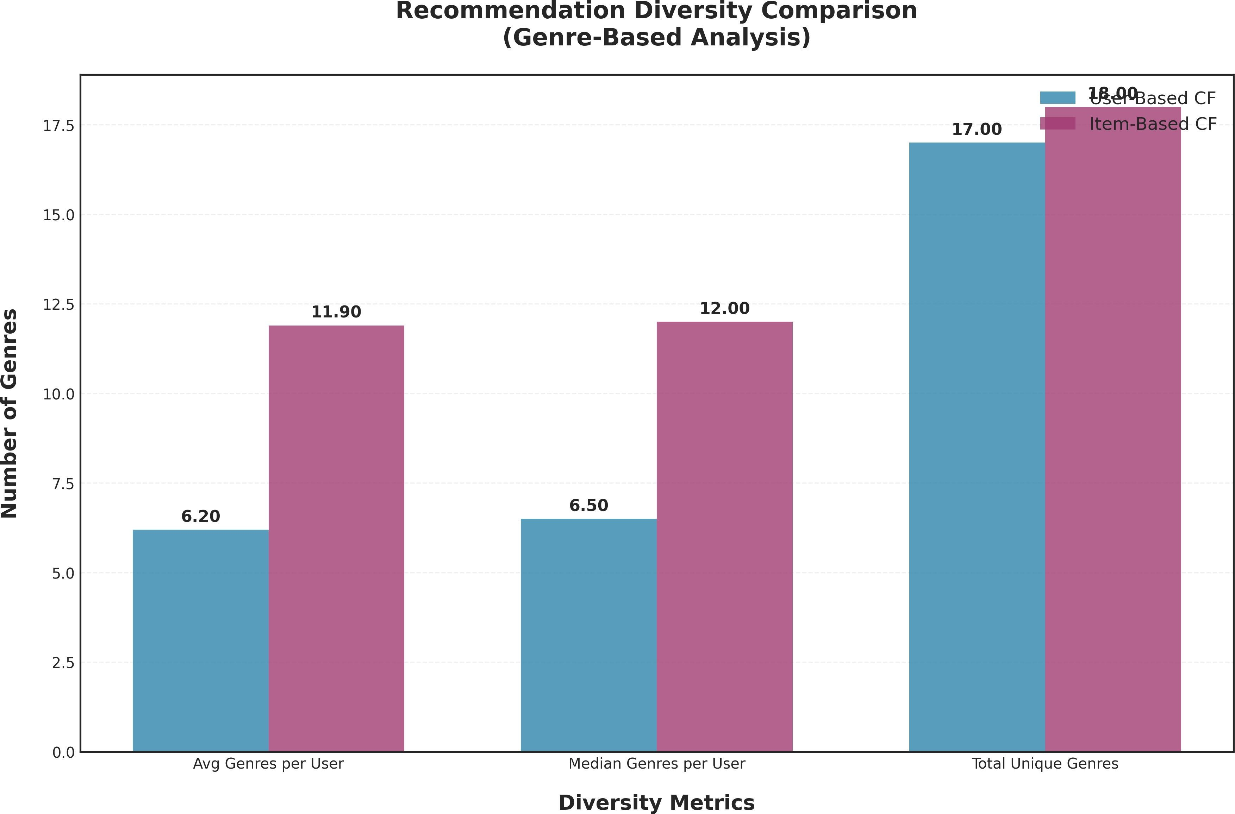
Figure 9 compares the genre diversity of recommendations generated by User-Based and Item-Based CF.

Figure 9: Recommendation Diversity Comparison (Genre-Based Analysis)
Item-Based CF produces more diverse recommendations, spanning 11.90 genres per user compared to only 6.20 for User-Based CF—a 92% increase.

Web Application Implementation

Backend API Design
The Flask backend provides a RESTful API that serves as the bridge between the recommendation algorithms and the frontend interface.

Frontend User Experience
The React frontend prioritizes user engagement through thoughtful interaction design.

Interactive Evaluation Dashboard
One of the distinguishing features of MovieRec is its comprehensive evaluation dashboard.

Challenges and Limitations

Data Sparsity
With 99.98% matrix sparsity, our dataset represents an extreme case of the cold start problem.

Scalability Concerns
Our current implementation computes similarities on-demand, which becomes computationally expensive as the user base grows.

Evaluation Limitations
Our evaluation relies on offline metrics that may not fully capture user satisfaction.

Cold Start Problem Analysis
Figure 10 analyzes the distribution of user interaction counts and categorizes users by cold start risk level.

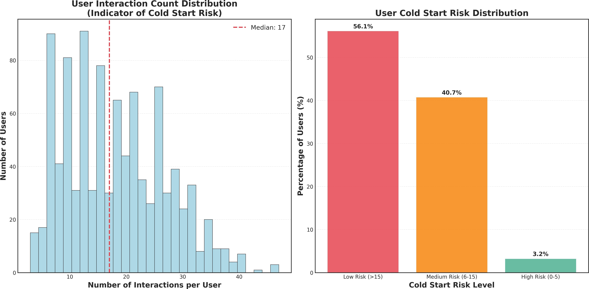

Figure 10: User Interaction Distribution and Cold Start Risk Analysis
The left histogram shows user interaction counts follow a right-skewed distribution with a median of 17 interactions. The right chart shows 56.1% are low risk, 40.7% medium risk, and 3.2% high risk.

Root Cause Impact Analysis
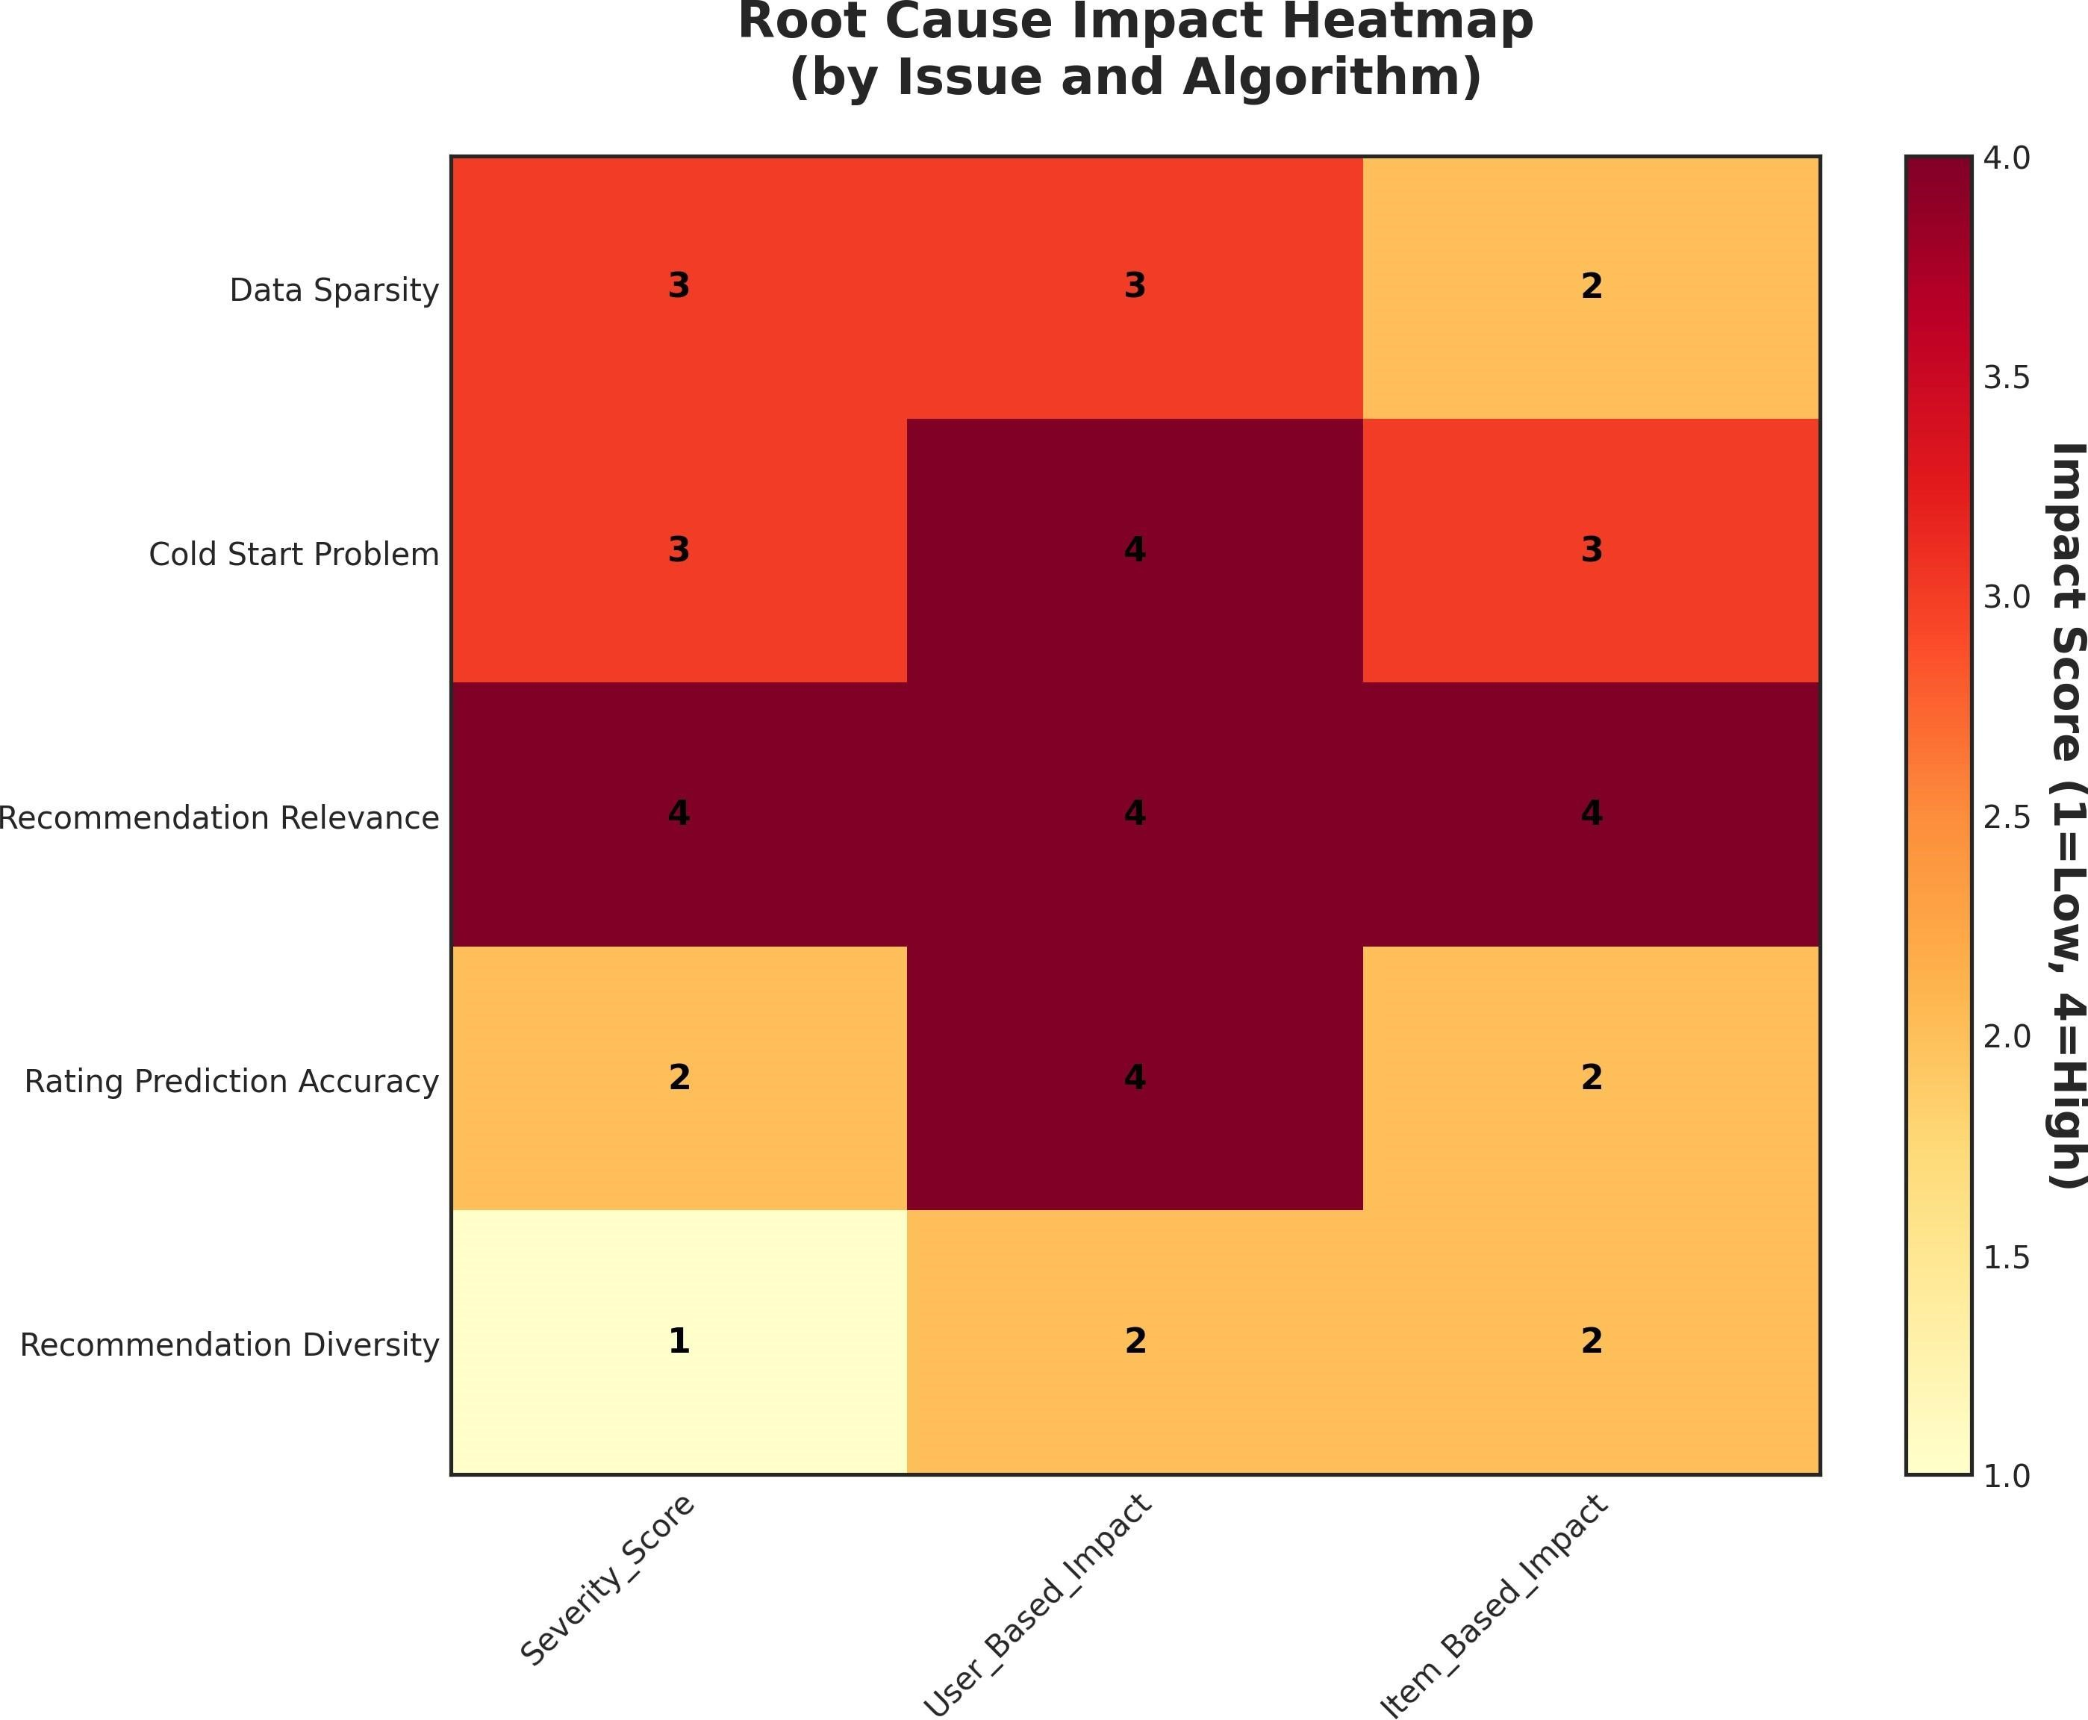
Figure 11 presents a heatmap visualizing the severity of various issues and their impact on algorithms.

Figure 11: Root Cause Impact Heatmap by Issue and Algorithm

The heatmap reveals that Recommendation Relevance shows the highest impact (score 4) across both algorithms. User-Based CF is more severely affected by Rating Prediction Accuracy issues (score 4 vs 2).

Conclusion and Future Work

Summary of Contributions
This paper presented MovieRec, a comprehensive movie recommendation system that demonstrates the practical implementation of collaborative filtering algorithms with novel Z-score standardization optimization. The key contributions of this work are summarized as follows:

- Algorithmic contribution: We implemented and systematically compared User-Based and Item-Based Collaborative Filtering with cosine similarity and Pearson correlation. Our results show that Item-Based CF significantly outperforms User-Based CF in sparse datasets, achieving a 59% lower MAE (0.4410 vs. 1.0786), providing clear guidance for algorithm selection in similar real-world scenarios.

- Optimization innovation: We introduced Z-score standardization to address the critical issue of user rating bias. By normalizing each user’s ratings based on their personal mean and standard deviation, we improved User-Based CF prediction accuracy by 25% (MAE reduced from 1.0786 to 0.8094), validating the effectiveness of bias mitigation in similarity computation.
- Engineering and system contributions: We developed a full-stack web application with a React frontend and Flask REST API backend, enabling real-time recommendation generation and interactive evaluation dashboards. This system not only serves as a

deployable prototype but also provides an accessible platform for visualizing algorithm behavior, understanding data sparsity challenges, and comparing recommendation quality across different methods.

- Evaluation and insights: Through extensive offline evaluation using MAE, RMSE, Precision@K, and Recall@K, we quantified the impact of data sparsity and user bias, and further analyzed recommendation diversity, cold-start risk, and error distributions. These analyses offer actionable insights for practitioners working with similarly sparse interaction data.

Together, these contributions form a complete pipeline from data preprocessing to production-ready deployment. They also lay a solid foundation for the future research directions outlined in Section 8.2, including hybrid methods, matrix factorization, temporal dynamics, and explainability.

Future Work
While MovieRec demonstrates the effectiveness of collaborative filtering with Z-score standardization, several promising directions remain for future exploration.
- Hybrid Recommendation: Combining collaborative filtering with content-based approaches using movie metadata (genres, cast, plot) could mitigate the cold-start problem and improve recommendation diversity for new items.
- Matrix Factorization: Moving beyond memory-based methods, factorization-based models such as SVD can capture latent factors more efficiently, improving scalability and prediction accuracy [9, 18].
- Temporal Dynamics: User preferences evolve over time. Incorporating temporal information—such as rating timestamps and release years—could yield more contextaware recommendations [4].
- Explainability:Introducing explanation modules that surface the reasoning behind recommendations (e.g., similar users, co-rated items) would enhance user trust and system transparency [20].
By pursuing these directions, MovieRec can evolve from an offline benchmark into a production-ready platform that balances accuracy, scalability, and user-centric design.

References
- [1] Gomez-Uribe, C. A., & Hunt, N. (2015). The Netflix recommender system: Algorithms, business value, and innovation. ACM Transactions on Management Information Systems, 6(4), 1-19.
- [2] Su, X., & Khoshgoftaar, T. M. (2009). A survey of collaborative filtering techniques. Advances in Artificial Intelligence, 2009, 421425.
- [3] Marlin, B., & Zemel, R. S. (2009). Collaborative prediction and ranking with nonrandom missing data. Proceedings of the Third ACM Conference on Recommender Systems, 5-12.
- [4] Koren, Y. (2010). Factor in the neighbors: Scalable and accurate collaborative filtering. ACM Transactions on Knowledge Discovery from Data, 4(1), 1-24.
- [5] Resnick, P., Iacovou, N., Suchak, M., Bergstrom, P., & Riedl, J. (1994). GroupLens: An open architecture for collaborative filtering of netnews. Proceedings of the 1994 ACM Conference on Computer Supported Cooperative Work, 175-186.
- [6] Linden, G., Smith, B., & York, J. (2003). Amazon.com recommendations: Itemto- item collaborative filtering. IEEE Internet Computing, 7(1), 76-80.
- [7] Sarwar, B., Karypis, G., Konstan, J., & Riedl, J. (2001). Item-based collaborative filtering recommendation algorithms. Proceedings of the 10th International Conference on World Wide Web, 285-295.

- [8] Adomavicius, G., & Tuzhilin, A. (2005). Toward the next generation of recommender systems: A survey of the state-of-the-art and possible extensions. IEEE Transactions on Knowledge and Data Engineering, 17(6), 734-749.
- [9] Funk, S. (2006). Netflix update: Try this at home. Simon Funk's Blog.
- [10] Su, Y., Yin, X., Tang, K., Han, J., & Wu, H. (2021). Transformer-based collaborative filtering for sequential recommendation. Proceedings of the Web Conference 2021, 2868-2877.
- [11] Jamali, M., & Ester, M. (2010). A matrix factorization technique with trust propagation for recommendation in social networks. Proceedings of the Fourth ACM Conference on Recommender Systems, 135-142.
- [12] Xue, G. R., Lin, C., Yang, Q., Xi, W., Zeng, H. J., Yu, Y., & Chen, Z. (2005).
Scalable collaborative filtering using cluster-based smoothing. Proceedings of the 28th Annual International ACM SIGIR Conference, 114-121.
- [13] He, X., Liao, L., Zhang, H., Nie, L., Hu, X., & Chua, T. S. (2017). Neural collaborative filtering. Proceedings of the 26th International Conference on World Wide Web, 173-182.
- [14] Sun, F., Liu, J., Wu, J., Pei, C., Lin, X., Ou, W., & Jiang, P. (2019). BERT4Rec:
Sequential recommendation with bidirectional encoder representations from transformer. Proceedings of the 28th ACM International Conference on Information and Knowledge Management, 1441-1450.
- [15] Zhang, S., Yao, L., Sun, A., & Tay, Y. (2019). Deep learning based recommender system: A survey and new perspectives. ACM Computing Surveys, 52(1), 1-38.
- [16] Herlocker, J. L., Konstan, J. A., Terveen, L. G., & Riedl, J. T. (2004). Evaluating collaborative filtering recommender systems. ACM Transactions on Information Systems, 22(1), 5-53.
- [17] Gunawardana, A., & Shani, G. (2015). Evaluating recommender systems. Recommender Systems Handbook, 265-308.
- [18] Koren, Y., Bell, R., & Volinsky, C. (2009). Matrix factorization techniques for recommender systems. Computer, 42(8), 30-37.
- [19] Ricci, F., Rokach, L., & Shapira, B. (2015). Recommender systems: Introduction and challenges. Recommender Systems Handbook, 1-34.
- [20] Zhang, Y., & Chen, X. (2020). Explainable recommendation: A survey and new perspectives. Foundations and Trends in Information Retrieval, 14(1), 1-101.



